**Flume Installation**

First, Download Flume from official website.

Flume is a product of apache, so we will use apache website to download.

* https://archive.apache.org/dist/flume/1.9.0/

1. **Graphical user: -**

* Open the browser.
* Type url in the browser.
* Click on apache-flume-1.9.0-bin.tar.gz

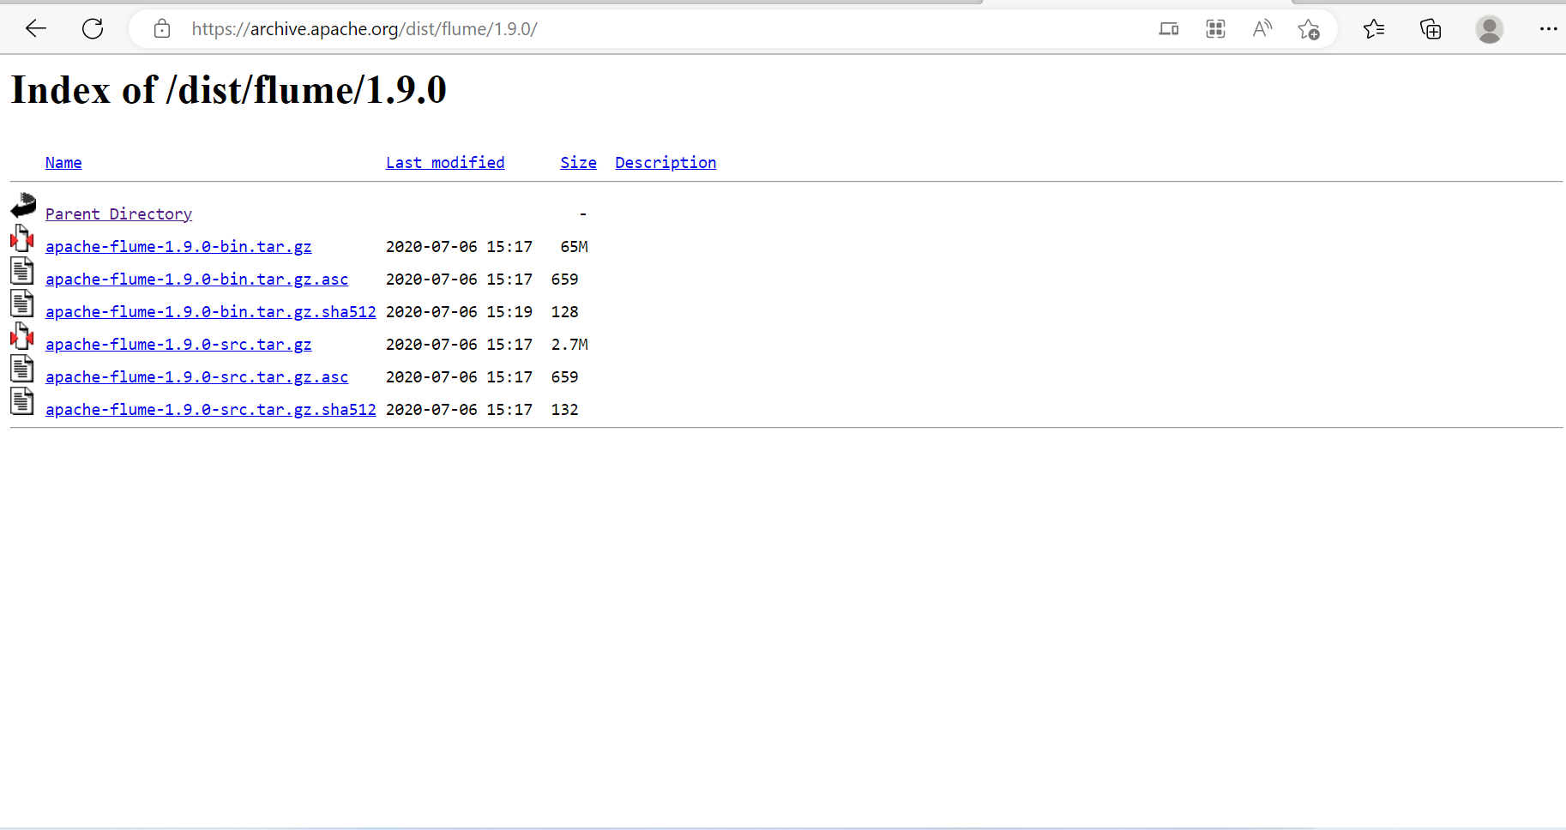

* Click on it and your download will start.

1. **CLI:- with the help of terminal we can download.**

* Open terminal.
* go to download directory.
* pwd to check.
* Type command.
* $wget <https://archive.apache.org/dist/flume/1.9.0/apache-flume-1.9.0-bin.tar.gz>

1. **Unzip Flume :-**

* $tar –xvf apache-flume-1.9.0-bin.tar.gz

1. **Rename Flume**

* $mv apache-flume-1.9.0-bin.tar.gz flume

1. **Move Flume in training directory.**

* $mv flume /training/

1. **Set Enviroment.**

$ sudo vi .bash_profile

export FLUME_HOME=/training/flume/

export PATH=$PATH:$FLUME_HOME/bin

:wq! Save and exit.

$source .bash_profile

1. **Find Java Location.**

$JAVA_HOME

Copy location

1. **Rename flume-env.sh template**

$mv /training/flume/conf/flume-en.sh.template /training/conf/flume-en.sh

$ vi /training/flume/conf/flume-env.sh

Export JAVA_HOME=/training/jdk1.8.0_241

Paste location of java

1. Verify Flume

$flume-ng version

Ready to use.